Data specifications

Alouette-I Ionograms

The Alouette-I Program
A joint U.S./Canadian effort to investigate the global structure of the upper ionosphere was initiated at the end of 1958. The basic concept of the experimental approach was to explore the upper (or topside) ionosphere from a satellite by the same ionosonde (or sounder) technique which had been used for several decades from the ground. The satellite version of the ionosonde became known as the topside sounder (Franklin and Maclean, 1969), and until 1963, the related U.S./Canadian effort was named the Topside Sounder Program. This program led to Alouette-1, the first topside sounder satellite launched on September 29, 1962.
Designed and assembled in Canada, Alouette-I was the first satellite built by a nation other than the United States or the Soviet Union (the launch vehicle was provided by the United States). It was constructed at a time when most satellites had a useful lifespan of a few months. Although Alouette-I was as complex as any previously launched satellite, rapidly advancing technology and the extreme care exercised in all phases of the Alouette-I development had led the Canadian builders to expect that their satellite would operate for at least 1 year. Their most optimistic prediction was 5 years of declining usefulness. No one, least of all the project team, would have dreamed of the 10-year life that was actually achieved by Alouette-I.

The Scientific Mission
In its first 3 months of operation, Alouette-I produced some of the most exciting data obtained during the entire 50-year history of ionospheric research, and it continued to provide valuable information until its tenth birthday. Alouette-I is best known for its swept-frequency topside sounder experiment. The other experiments (VLF, cosmic noise, and energetic particle measurements) were, however, equally successful and they also remained operational for 10 years. The Alouette-I mission resulted in over 300 publications in refereed scientific journals. About 80 percent of the Alouette-I publications were based on the ionograms obtained from the topside sounder experiment. In its first 3 years of operation, Alouette-I obtained over a million ionograms, each equivalent to a snapshot of the ionosphere from the Alouette-I altitude of 1000 km down to an altitude of about 300 km. These ionograms have provided data at all geomagnetic latitudes and at geographic latitudes ranging from 80° N to 80° S. After 10 years, Alouette-I had produced two million ionograms.

The Alouette-I Data
The great majority of these ionograms are still archived on 35 mm negative film rolls, a format which is not very convenient for research. The Canadian Space Agency (CSA) has recently started to digitize some of these films and provide them to the public through the Open Data Portal of the Government of Canada (http://open.canada.ca/en/open-data). Several challenges remain:
Although this data dates back from the ‘60s, there is still a significant scientific interest in analyzing this data to better understand the ionosphere.
Figure 1 presents a typical ionogram. Vertical lines are time/frequency markers spaced by approximately one second. Time is directly related to the frequency variation of the transmitted signal by the satellite (linear frequency scan from 0.5 to 11.5 MHz in approximately 15 seconds). Horizontal lines are 100 km distance markers from the satellite. The zero distance (location of satellite) being at the top of the image.
The interesting data on these ionograms is the “hockey-stick shaped” cloud of points representing the “echoes” or “reflections” of the signal by the ionosphere. The strong reflection at 1000 km depth is from the Earth’s surface. The ionosphere is more or less reflective depending on the frequency of the signal. Each dot of the cloud is referenced by the Frequency (horizontal axis) of the signal and Depth (vertical axis) of reflection (Depth = Time delay to receive the echo x Speed of light / 2). The echoes are used to estimate of the distance and frequency-dependent reflection of the ionosphere with regards to the satellite’s position.
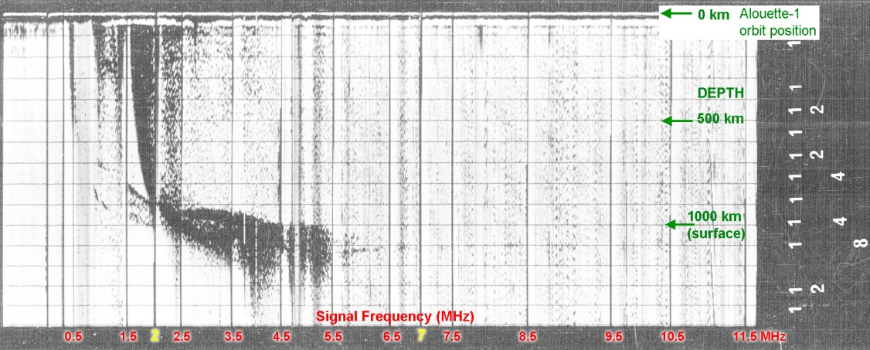
Fig. 1) Frequency and Depth Markers
- On Alouette-I, the frequency varied from 0.5 MHz to 11.5 MHz over 15 seconds
- The frequency is increased almost linearly at a rate of 1 MHz/per second.
- Frequency markers are provided at 1 MHz intervals, beginning at 0.5 MHz
- To assist in the identification of these markers, broader markers were provided at 2 MHz and 7 MHz (Note: Human hearing range is ~20 Hz – 20 KHz)
- The standard virtual depth (height) scale is 1500 km with markers at every 100 km.

Digital coding of the ionograms metadata
The ionogram metadata is located on the right side of ionograms and each digit is coded in digital format. Values must be summed along the 13 columns to be interpreted. A zero is coded as a blank space. Table 1 provides the key to the station’s ID. Figure 2 provides the interpretation key of the ionogram’s Digital Codes (DC).

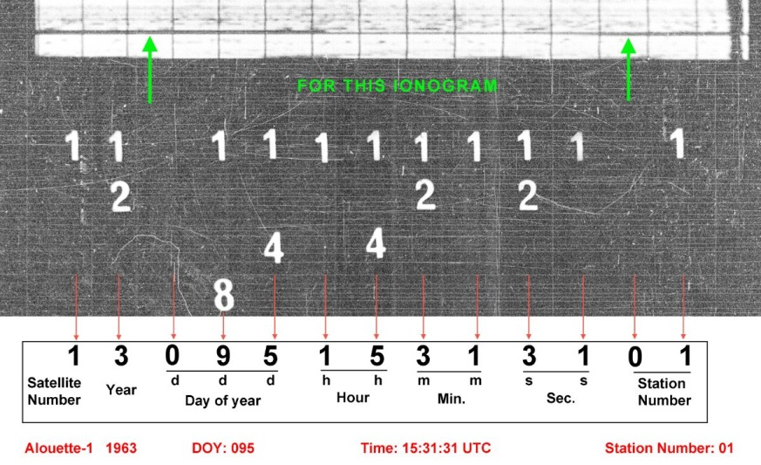
Fig. 2) Interpretation of the ionogram’s metadata with digital codes. Coloured lines and numbers have been added to facilitate comprehension of the diagram.

Binary coding of the ionograms metadata
Some ionogram’s metadata are encoded using a Binary Dot Code as shown on Figure 3. In this case, the information is coded under four rows of dots representing values of 1, 2, 4 and 8 (top to bottom) and under 10 columns. Digital value of each column is obtained by adding the values of each column with a blank column representing a value of zero.
Station code is always close to the top of the ionogram. The first, second and third columns gives the Day Of Year (001 to 365); the fourth and fifth give the hour; the sixth and seventh give the minutes; the eighth and ninth represent the seconds; the tenth digit providing the station code number.
For example, for the example in figure 3 below, we would have the values: 3, 0, 6, 0, 2, 2, 4, 5, 9, 5 that can be translated to: Day of year 306, 02 hours, 24 minutes, 59 seconds, Station Code # 5. Note that the position of the dots is not always precise and may show some distortion.

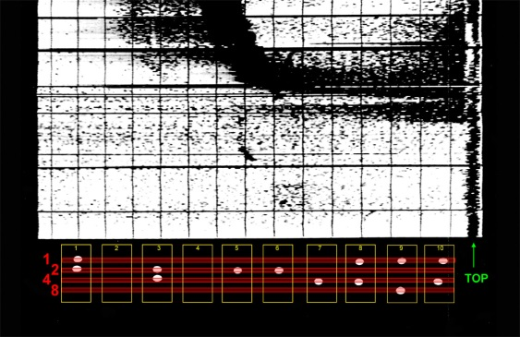
Fig. 3) Interpretation of the ionogram’s metadata with binary digital dots codes. Coloured lines and numbers have been added to facilitate comprehension of the diagram.
Station Number* | Station Name
01 | Resolute Bay, NWT
02 | Prince Albert, AB
03 | Ottawa, ON
04 | St John’s, NL
05 | Fairbanks, AK, USA
06 | Fort Myers, FL, USA
07 | Quito, Ecuador
08 | Antofagasta, Chile
09 | Falkland Islands, UK
10 | Winkfield, UK
11 | Singapore, Malaysia
12 | Woomera, Australia
13 | Grand Forks, MN, USA
14 | Blossom Point, MD, USA
15 | South Point, HI, USA
16 | Johannesburg, South Africa
17 | Mojave, CA, USA
18 | Winkfield, UK (2?)
19 | Fairbanks, AK, USA (2?)
20 | Rosman, NC, USA
*Station number prior to July 1965.
Table 1) Ionograms reception facilities and stations ID (partial list).

Scanning work description
A total of 454 Alouette-I rolls were converted from microfilm to 400 DPI uncompressed Tiff. Each film roll contained between 475 to 500 images.

Each roll was scanned by the service provider and saved as one single electronic folder which referred to the roll unique ID. Each individual image files were identified sequentially in order, from the beginning to the end of roll. In each of these 454 folders, every image became a separate file in: TIFF-8 format / 400 DPI (loss-less compression).

Equipment used for scanning : Windows XP computer and Mekel 625 Microfilm Scanner.

Issues and Resolution
The service provider ran into several issues and resolved them all:
- No leads on rolls: added leads
- Rolls reversed: rerolled then
- Images with no dots: scanned as well
- Long blank spaces: advanced rolls to more data
- Orientation issues: corrected orientation.

Roll number | Metadata Type | Issues resolved
500 | Digital | Blank spaces, distorted images, stretch distorted images. numbers with no images, Images with no numbers
502 | Digital | Long blank spaces, distorted images, stretch distorted images. numbers with no images, Images with no numbers, Light then dark
503 | Binary | Blank spaces, distorted images, stretch distorted images. dots with no images, Images with no dots,
504 | Digital | Blank spaces, distorted images, stretch distorted images. numbers with no images, Images with no numbers
505 | Binary | Long blank spaces, distorted images, stretch distorted images. numbers with no images, Images with no numbers
506 | Binary | Long blank spaces, distorted images, stretch distorted images. dots with no images, Images with no dots,

Information Extraction
Data sets that cover multiple solar cycles (each cycle being 11-13 years long) are rare and extremely valuable, in that they can provide crucial information about long-term changes and about infrequent events that may be difficult to capture in campaign-style observations. Fifty four years later, this data still has a significant scientific value. We now have a better understanding of the influence of the Sun on the Earth’s magnetosphere but there is still much work to be done!
Before scientists can start working on the meaningful data, many operations should be performed. We understand that these are not obvious tasks and that it is likely to be very time consuming. Here is a list of potential task to explore. Your feedback is very welcomed!
- Extracting and archiving the metadata in a form that makes it easy to find relevant data;
- Identify the useful ionograms and flag those that are useless;
- Can the Noise/Artefacts be removed while safeguarding the important data or is it better to leave it there so the user can do its own interpretation? Scratches, dust, film grain, noise, horizontal and vertical banding, overlaying graphs, these are just a few of many problems that we have observed on the films;
- Finding the Time/Frequency and Depth information from each graph to create the appropriate reference system for the data;
- Extracting the reflection data with the appropriate Time/Frequency and Depth coordinates;
- Can we stretch/squeeze the images to normalize the horizontal axis so each ionogram can be compared or batch-processed?
- Can we feed the full images to a model of the ionosphere that can be fitted to reproduce the echoes?
- Could part of the work be done through Crowd Sourcing?
The ISIS/Alouette Topside Sounder Data Restoration Project (https://spdf.gsfc.nasa.gov/isis/isis-status.html) has lots of relevant information that should be helpful for those who want to attempt working with Alouette-I data.

The ionosphere is a region of Earth's upper atmosphere ionized by solar radiation. It spans from about 90 km to 1,000 km altitude. The ionosphere plays an important role in atmospheric electricity and forms the inner edge of the magnetosphere. It has practical importance because, among other functions, it influences the propagation of electromagnetic waves (radio communications, GNSS signal propagation, etc.).

